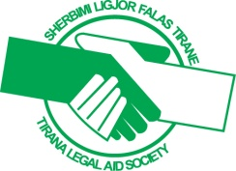
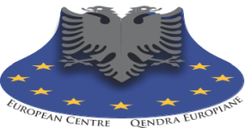
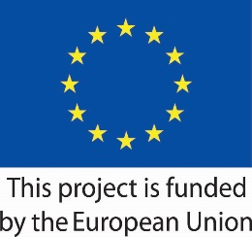

Contributing in the Amelioration of Human Rights Standards in and out the Penitentiary Systemin Albania

TERMS OF REFERENCE
National Legal Experts

Description of the project

The project “Contributing in the amelioration of human rights standards in and out the penitentiary system in Albania” has started in February 2020, aiming at promoting a functional system of protection and prevention for persons deprived of their liberties and upon release, in full compliance with European standards and recognised international principles.
The program main outcomes are (O.1). Rehabilitative approach to prison and probation management (education / legal / psycho-social and vocational support) fostered and rehabilitation and prevention prospects of prisoners improved; (O.2). An interactive platform to support CSO active in the field of human rights education and litigation; (O.3). All-of-government approach and engagement of civil society organizations in prison and probation settings enhanced, in particular in the field of fostering the crime prevention approach (including social reintegration of prisoners upon release).
During the upcoming months of project implementation, TLAS and its implementing partner organization European Centre Foundation will dedicate tailored interventions that orient legal education, strategic litigation and vocational education to inmates; promote standards of adequate psycho-social counselling for prisoners and prison staff; engage professional active civil society actors to consolidate and prioritize treatment and services in places of deprivation of liberties (through sub-granting process), having a consolidated partnership and support by the Albanian Ministry of Justice through General Directorate of Prisons and Probation Service).

Objective
The TLAS and ECF are looking for three national experts with relevant experience in the field of justice, especially on basic rights of persons deprived of their liberties, who will be responsible on development of the Workshops Modules (methodology) on legal aid, education and rehabilitation. In addition, the experts will be responsible on all workshops of the prisons staff on rehabilitation process.
The experts will design and deliver tailored workshops curricula as well.
Duties and responsibilities
For the prisons staff’s workshops, TLAS and ECF will require the services of three national experts who will be responsible to deliver workshops on prisons staff on rehabilitation process. The experts will design and deliver tailored workshop curricula as well.
The various topics for the workshop’s modules will be related to:
- coordination of common practices for the rehabilitation of convicts;
- the role of independent mechanisms and institutions in the protection of fundamental rights, such as the Ombudsman / NPM, the Commissioner for Protection from Discrimination, legal aid, etc;
- rehabilitation and reintegration - as concepts that need to be improved and strengthened for certain categories of convicts such as women, juveniles and convicts with special needs;
- treatment of persons with mental health disorders into the context of deprivation of liberty.
More specifically, the expert will have to:
- Deliver of cascade of 6 Workshops;
- To deepen the prisons staff’s knowledge on fair trial standards, fair treatment standards and European human rights standards;

Expected Outputs/Deliverables
- Prepare workshops methodology;
- Deliver 6 workshops;
- Training materials for prisons staff on rehabilitation process;

Necessary Qualifications
- University degree in law;
- At least 10 years of professional experience: work experience in public or human rights law/EU law or penitentiary system;
- Academic and teaching experience;
- Previous experience with TLAS and ECF as legal expert would be an asset;
- Very good writing skills;
- Very good communication skills;
- Ability to work with minimal supervision;
- Excellent knowledge of Albanian and international standards;
- Very good reporting skills.

Location
The delivery of trainings will take place online based on the restrictions posed by the global Pandemic situation.

Application process

Applications should be submitted to eidhr.tlas@gmail.com latest by September 20, 2020.

The candidates are required to submit a CV with description of relevant work experience and qualifications, and a financial offer for 8 (eight) working days indicating the daily rate.

The Program Management will contact only shortlisted experts.

The Payment
The payment will be made in one instalment upon the satisfactory completion of all deliverables.

TLAS is committed to maintaining an environment of mutual respect, where equal employment opportunities are available to all applicants.

